Olusegun Afolabi
EECE 412
Professor Wenjie
2/10/2025

Lab 2: Create a Testbench for ‘even_detector’
Introduction
This lab focuses on designing and verifying a testbench for the even_detector.vhd digital circuit done in lab 1. The testbench ensures the correctness of the even_detector module using behavioral simulation in Vivado. Through this process, we explore the functionality of the circuit and validate its output using a structured testing methodology.
This lab was completed using the following tools and applications:
- Vivado Design Suite: Used for creating the project, adding design files, and running behavioral simulations.
- VHDL: The hardware description language used to implement and verify the even_detector circuit.
- Basys 3 FPGA Board: The target hardware platform used for potential real-world implementation.
- Simulation and Waveform Analysis: Performed within Vivado to verify correct circuit functionality.

Concept
The even detector is a digital circuit that determines if a 3-bit binary input represents an even number. The expected behavior is:
- Outputs 1 if the input is even.
- Outputs 0 if the input is odd.
Truth Table:
Input A | Input B | Input C | Expected Output
0 | 0 | 0 | 1
1 | 0 | 1 | 0
10 | 1 | 0 | 0
11 | 1 | 1 | 1
100 | 0 | 0 | 0
101 | 0 | 1 | 1
110 | 1 | 0 | 1
111 | 1 | 1 | 0

Procedure
Step 1: Project Setup
- Created a new project in Vivado, ensuring that VHDL was selected and the Basys 3 board was chosen.
- Copied even_detector.vhd from lab1/VHDL/ to lab2/VHDL/.
- Added the design file to the project and included the Basys 3 Constraint file.
Step 2: Testbench Creation
- Copied the testbench VHDL code and created tb_even_detector.vhd.
- Added the testbench file to the sources as a simulation source.
Step 3: Simulation Execution
- Selected Simulation in the Flow Manager.
- Ran the Behavioral Simulation and observed waveform outputs.
- Captured screenshots of test inputs and outputs.
Simulation and Results
The following images display the simulated results for various input values:
- Input: 000 → Output: 1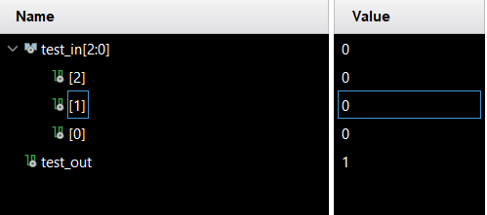

- Input: 001 → Output: 0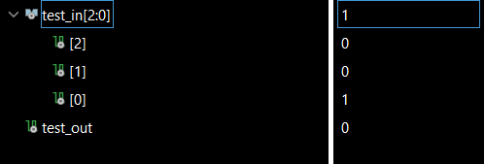
- Input: 010 → Output: 0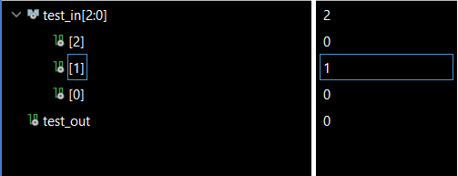
- Input: 011 → Output: 1
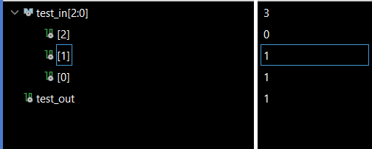
- Input: 100 → Output: 0
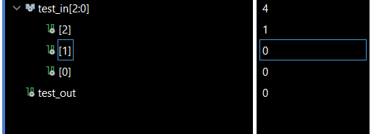
- Input: 101 → Output: 1
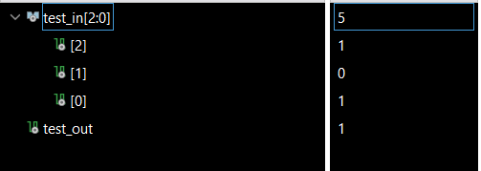
- Input: 110 → Output: 1
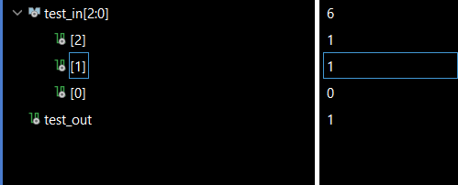
- Input: 111 → Output: 0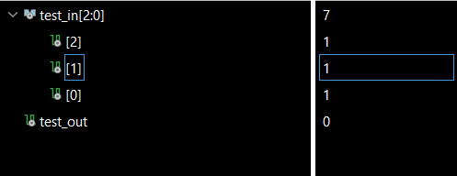
Explanation of Results
The observed outputs align with the expected behavior of the even detector circuit:
- Inputs that represent even numbers correctly produce an output of 1.
- Inputs that represent odd numbers correctly produce an output of 0.
No discrepancies were observed between the expected and simulated outputs.
Conclusion
This lab successfully implemented and verified the even_detector testbench. The behavioral simulation confirmed that the circuit functions as expected. Through this process, I gained a deeper understanding of:
- Testbench creation in VHDL.
- Behavioral simulation techniques in Vivado.
- The importance of structured testing and waveform analysis.
This knowledge sets a foundation for more complex digital system verification in future labs.

